Lewis Nordan

Homework 1 – Gallimaufry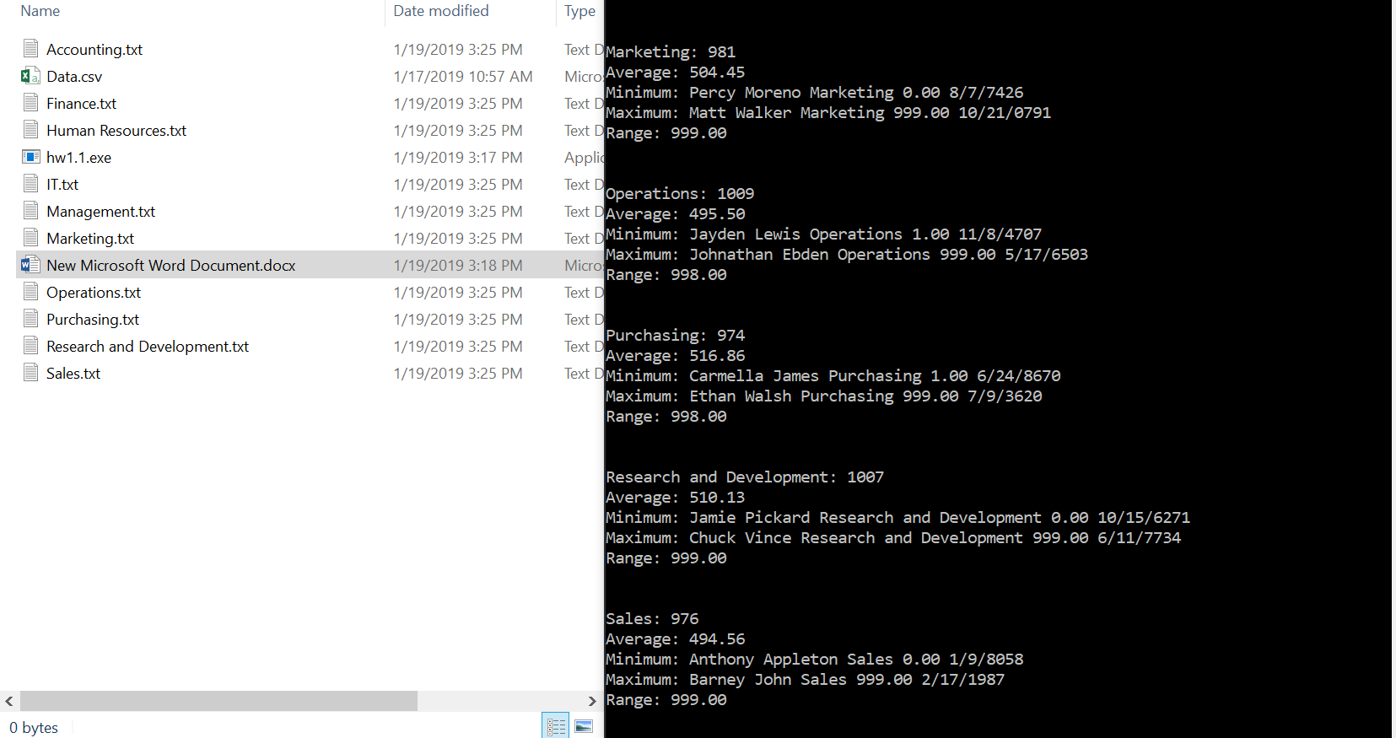

I used a vector as my STL container. i found that using a set would not work very well. If there were 2 data entries that had the same price, then there would be missing data. I didn’t use a map because I had no need for a key. The other option that I could have used was a list and this would have worked just fine. However, I was unsure if I wanted to use random access in this program, so I opted for the vector.